Zara Sabri (F2024065489)
Software Engineering (W2)

Assignment: 3
Question 1:
- Construct a Context Diagram showing the system boundary and its interaction with external entities.
Description
The Context Diagram represents SOFTNEX as a single system and shows how it interacts with external entities. It clearly defines the system boundary and external data exchanges.
External Entities
- User – Uses the system to register, login, manage tasks, view dashboard
- Admin – Manages users, roles, tasks, and reports
- Email Service API – Sends notifications and verification emails
- Database Server – Stores system data
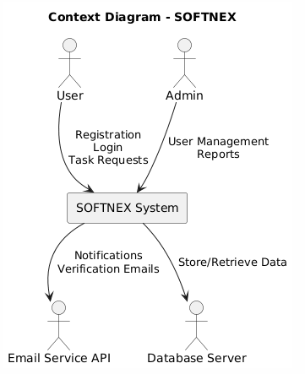
- Convert the Context Diagram into a Data Flow Diagram (DFD) Level 0, identifying the major processes and data flows.
Description
DFD Level 0 expands the system into major processes and shows how data flows between entities, processes, and data stores.
Major Processes
- User Management
- Task Management
- Report Generation
- Notification Handling
Data Stores
- D1 – User Database
- D2 – Task Database
- D3 – Report Database
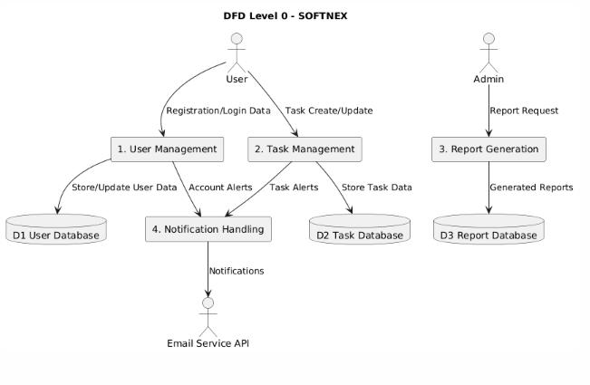

- Draw an Entity Relationship Diagram (ERD) representing the system’s data entities and their relationships.
Description
The ERD shows the data structure of SOFTNEX, including entities, attributes, primary keys, foreign keys, and relationships.
Entities and Attributes
User
- User_ID (PK)
- Name
- Email
- Password
- Role

Admin
- Admin_ID (PK)
- Name
- Email

Task
- Task_ID (PK)
- Title
- Status
- Priority
- Deadline
- User_ID (FK)
Report
- Report_ID (PK)
- Report_Type
- Generated_Date
- Admin_ID (FK)
